Vernal Pools: One Consultants Perspective
by David Marceau

Site evaluators these days are being asked more and more to do things that are getting further and further away from the concept of designing a septic system. One example of this is being able to identify vernal pools. Vernal pools are important features for site evaluators to identify because the buffers around them can be very highly regulated in some circumstances. In Maine, the State of Maine DEP regulates “significant vernal pools” which include buffers. The DEP calls them critical terrestrial habitats. In some cases the U.S. Army Corp. regulates vernal pools and a larger buffer. Thus, if a site evaluator does not make it clear to his/her client that the work that is being done does not include identifying vernal pools he/she could be liable for not addressing this issue. If you make no explicit claim to address DEP related issues for your clients that might cover you for now. However, the current proposal for the Subsurface Code (available at http://www.maine.gov/dhhs/eng/plumb/about.htm) (see definitions in Chapter 3 and Table 700.1 for setbacks) includes a 25 foot setback for fill extensions to “significant vernal pools” among other things. That ties system locations directly to the need to identify significant vernal pools and awareness of the fact that a significant vernal pool is not only the pool itself, but the critical terrestrial habitat surrounding the pool as well. As you will see in the following paragraphs, this is broad topic.

The actual State law that regulates significant vernal pools took effect on September 1, 2007. However, because the process of identifying significant vernal pools requires that egg masses be counted in April and May the real work performed to identify these pools did not take place for the first time until this past spring. The law that regulates significant vernal pools falls under the umbrella of the State of Maine, DEP, Natural Resource Protection Act. More specifically, significant vernal pools are regulated by the Significant Wildlife Habitat Rules which is Chapter 335.

For those of you who are not familiar with the process of identifying a significant vernal pool it is cumbersome. The place to start is to determine whether or not you think there are any potential vernal pools within or adjacent to the area in which you want to develop. Keep in mind that development includes changing a wooded area to grass, i.e. septic systems. The DEP has established a 250 foot “critical terrestrial habitat” buffer whereas the U. S. Army Corp. of Engineers (ACOE) has discretionary authority to require a 500 foot buffer (or more) if they get involved with wetland impacts. The ACOE also has different standards for identifying vernal pools and may enforce other regulations that vary from the DEP.

Potential vernal pools are any area which you think might contain enough water in a shallow depression to allow for wood frogs, spotted salamander, blue-spotted salamander or fairy shrimp to reproduce (the definition also includes rare and endangered species but these are usually not a concern). My experience in observing vernal pools for the last five years or so has taught me that generally you need to have a minimum of water 12 inches or so deep for it to have potential to be significant. Otherwise the pool may allow amphibians to breed but the egg masses will not persist for long enough to allow them to develop into adults. Typically, the eggs are laid in April or May and metamorphose into adults by July or August. Running water may provide habitat for fish and moves too quickly to allow the type of amphibians we are concerned about to breed, so streams do not qualify as vernal pool habitat.

Once you have identified potential vernal pools then you need to determine if any are significant based upon the standards within Chapter 335. This essentially entails making observations of the potential vernal pools for amphibian egg masses or fairy shrimp during the time frame the DEP has established in your region. The northern region is anything north of the line extending from Fryeburg to Auburn to Skowhegan to Bangor to Calais (Wood Frogs May1 – May 21 and Spotted and Blue Spotted Salamanders May 10 - May 31) while anything south of that line is considered to be within the southern region (Wood Frogs April 7 – April 21 and Spotted and Blue Spotted Salamanders April 20 – May 21). In looking at the dates you might say what if things are colder or warmer than normal and the apparent observation period is obviously off. For example, I know of a significant vernal pool in Searsmont (the town I live in) that was frozen solid until April 21 last year. Obviously, I could not observe wood frog egg masses within that vernal pool during the time frame the rules state (April7 – April 21). When I called the DEP to ask the question they said the dates are guidelines and are not “firm”. When I asked how long the time frame for observations could or should be extended they said “check the web site”. Also, anyone who has worked along the coast knows that the ocean has a large effect on the warming and cooling trends so islands and peninsulas seem to be more like the northern region rather than the southern region, but, the rules don’t say that. So, there are numerous weather related issues that need to be worked out in order for projects to move forward.

Regarding the identification of amphibian egg masses there are problems as well. The presence of 40 or more wood frog egg masses, 20 or more spotted salamander egg masses or 10 or more blue-spotted egg masses make a vernal pool significant by DEP rules. Again the counting seems easy but wood frogs tend to lay their egg masses on coarse woody debris or emergent grasses in large clumps which can make deciphering between masses a problem. Some people say that if you get to the point where that is a problem the pool is significant anyway. I don’t agree; 40 egg masses is a lot and I have seen times when they are all laid in one small location within the pool.

In addition, deciphering between spotted salamander egg masses and blue-spotted egg masses is not easy. Spotted salamander egg masses are laid in clusters of 30 to 250, have a rather thick membrane around their eggs, and the masses are very firm (as determined by squeezing).

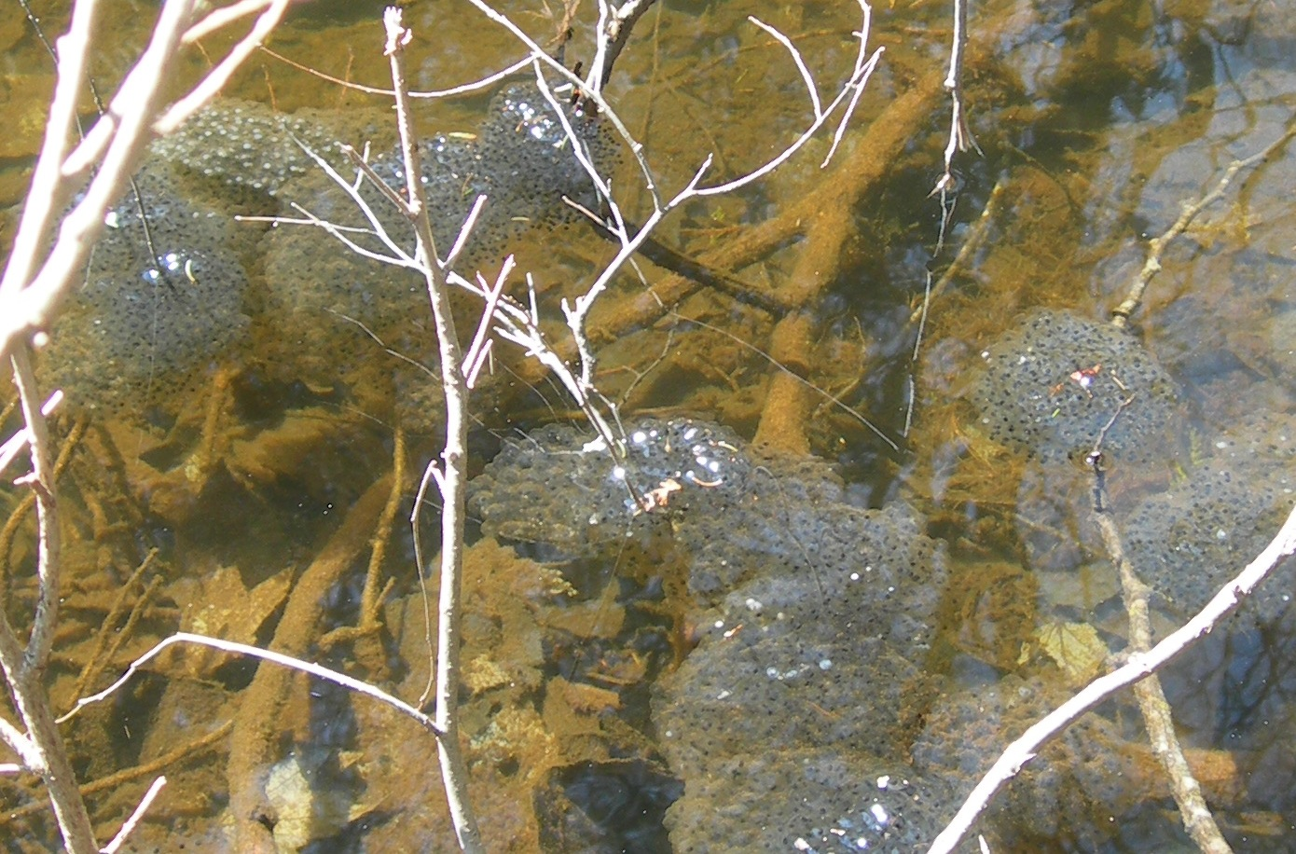

These are wood frog egg masses somewhat clumped together. Note the lack of thick membrane surrounding them.

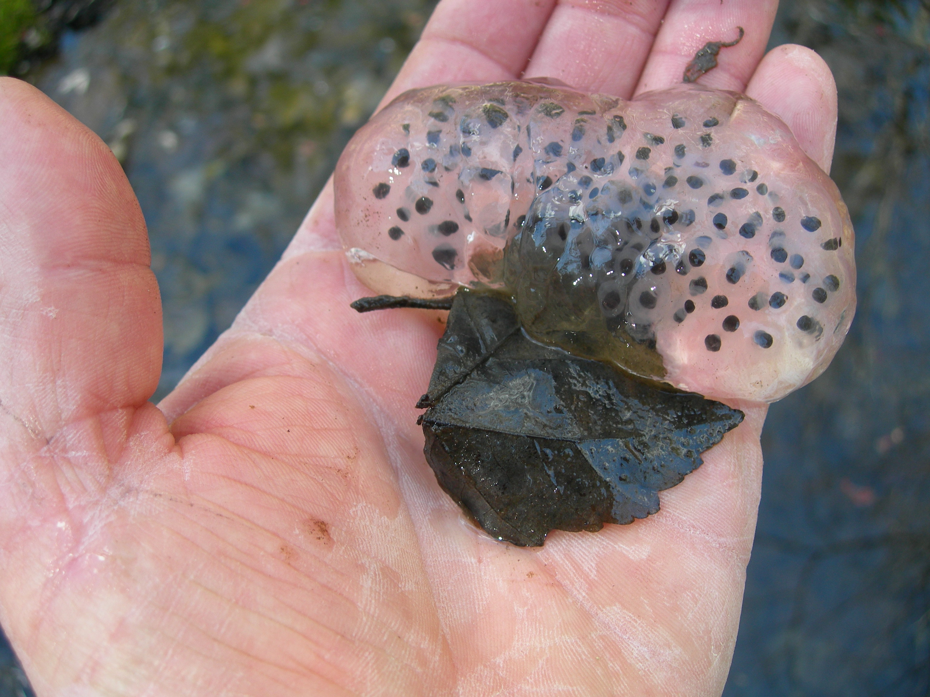

This is as picture of a Spotted Salamander Egg Mass. Note the thick, firm membrane surround the eggs.

Blue-spotted salamander eggs occur in masses of 1 to 30, are “loose”, and have a thinner membrane around them. The problem here occurs when you have about 30 eggs in a mass and the mass has decayed a bit so it is somewhat loose, and/or the individual eggs with the thickness of their membranes look more like blue-spotted than spotted. There are some vernal pools that I have been observing for 5 years where I have seen many adult blue-spotted salamanders in yet have never identified any egg masses that look like the blue-spotted egg masses shown in the reference manuals. Furthermore, there are few pictures in any manual that clearly depict the characteristics of amphibian egg masses. All of this leads me to believe that we don’t know as much as we think we know and the characteristics of egg masses are not well understood.

Another difficult part of the process is deciding whether to fill out the forms (more later on this), filling out the forms, then completing the process that you need to in order to document whether a vernal pool is significant or not. The actual forms have been compiled by and need to be submitted to the Maine Department of Inland Fisheries and Wildlife (MEDIFW) not the DEP as you might expect. This is because the DIFW are the people who are the experts regarding vernal pools not the DEP. This is a problem because the DIFW are not the regulators (as the DEP are) but are “advisory” to the DEP. Thus, the DIFW has no stated time frame for action to be taken on any request whereas the DEP has specific time frames in which they need to act.
Also, the DIFW has said they will not make a determination on the significance of vernal pools without a minimum of two separate observations being recorded during the time frame that eggs are present. To a degree this is understandable given that the two amphibians we must record data for have a somewhat different time frame in which they lay their eggs. However, the DEP rules make no mention of this. The bottom line is that the DEP can, and does, ignore the opinions of the DIFW if they so choose.

In addition to this, submitting the form means that the information probably goes on a State GIS layer and is documented so that all can see. So, you might think that you should fill out the form and submit it if you want to document the fact that a vernal pool is not significant. However, you need to remember that the ACOE has no threshold for significance like the DEP does and thus they could look at the DEP information and potentially take jurisdiction over something they otherwise would not have known anything about. In my opinion, this has the potential to be a serious liability issue for site evaluators.

My bet is that either you stopped reading this a few paragraphs ago or you are saying to yourself “why to heck is this Marceau guy so wound up about these rules”? The reason is due to the large buffers (referred to as “critical terrestrial habitat” by the DEP) that surround these habitats and what you can and can’t do within them. Basically, the DEP regulates impacts to anything within 325 feet of a documented significant vernal pool. The first 250 feet is considered to be the “critical terrestrial habitat” while the 75 feet beyond that is considered to be “adjacent”. The DEP allows 25 percent of the critical terrestrial habitat to be disturbed through a permit by rule process. However, this disturbance cannot be in a wetland because that wetland would be considered to be a wetland of special significance. Furthermore, the current proposal to the subsurface code requires a 25 foot setback to the 250 foot critical terrestrial habitat buffer around a significant vernal pool.

The location of property lines in relation to the pools is very important because the DEP tells us that you are not required to investigate properties you do not own, and, the 25 percent critical terrestrial habitat is based upon what you own, not the entire habitat of the pool. If you owned the entire area around a significant vernal pool the buffer would be nearly five acres (assuming the pool is very small). If the property line runs through the buffer the area you would be required to investigate could be significantly less.

Based upon my contacts with other consultants, lawyers, the DEP and land owners it seems to me that most people are taking the “don’t ask don’t tell” approach. This is understandable given that most towns do not have any vernal pool regulations, making an accurate determination may take 9 months or more, and dealing with the permit process can be very difficult.

If I had a wish list I would request that some additional indicators be allowed to be used during times of the year that the egg masses are not present so that determinations for significance could be made year round. These could include such things as the presence of the tadpoles and larvae of the wood frogs and salamanders, water depths, precipitation data and the presence or absence of other critters known to exist in vernal pools. This proposal could allow projects to keep moving without inordinate disruptions. At any rate, it looks like regulations related to vernal pools are here to stay and we as consultants are going to have to negotiate the process.

