Spruce Mountain High School Envirothon Team
Earns International Awards and Scholarships

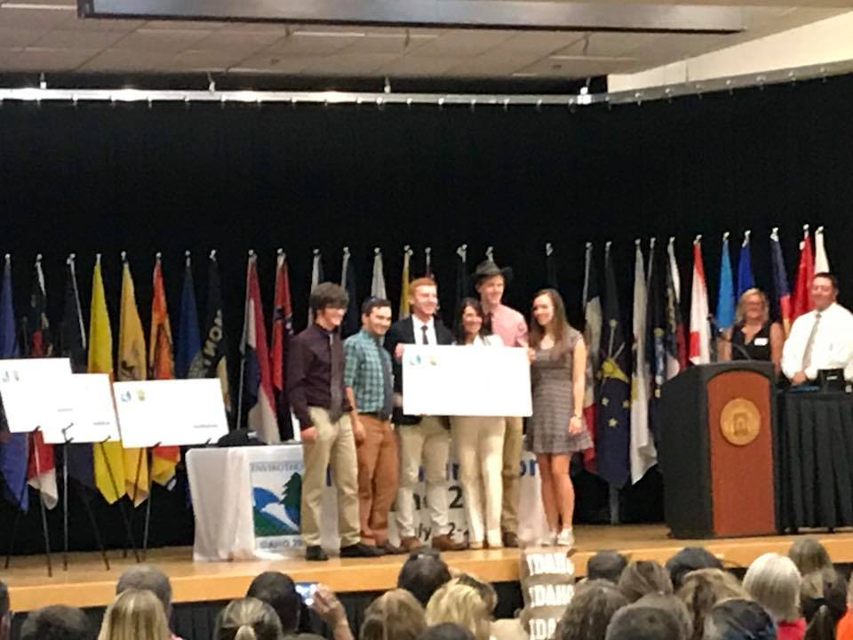
The Spruce Mountain High School Envirothon Team won first place in the Aquatic Ecology Competition and sixth place overall at the 2018 National Conservation Foundation (NCF) North American Envirothon competition at Idaho State University on Saturday July 27th. Envirothon is North America’s largest environmental science competition and the event in Pocatello, Idaho included 50 teams from across the United Stated, Canada, and two teams from China. The competition requires teams to learn about and complete field tests in Aquatic Ecology, Soil Science, Forestry, Wildlife, and this year’s current issue, Rangeland Management.
The Spruce Mountain Team that competed in Pocatello includes graduated Seniors Jordan Daigle and Rylee Delaney, as well as rising seniors John Brenner, Hunter Quirrion, and Orion Schwab. Spruce Mountain graduate Bryan Riley is also a member of the team, but was unable to attend the competition. All of the team members have been working together all year to prepare for Envirothon, and the team won Maine’s Regional and State Championships to qualify to compete in the NCF event. Since winning the State Championship on May 26th, the team has spent two months fundraising, studying, and meeting to prepare. Their efforts reaped rewards, as they received a $3500 check for scholarships for team members in recognition of their sixth place finish.
“The event is highly competitive,” said advisor Rob Taylor, who attended the week-long event along with school board member and parent chaperone Ann Schwab. “In a number of the tested areas, over a dozen teams scored over 90% and these are very challenging tests prepared by Idaho resource professionals. Only state and provincial champions from the US, Canada, and China competed. I believe 6th place may be the highest finish ever by a team from Maine.” Ann Schwab added, “This team is amazing!”
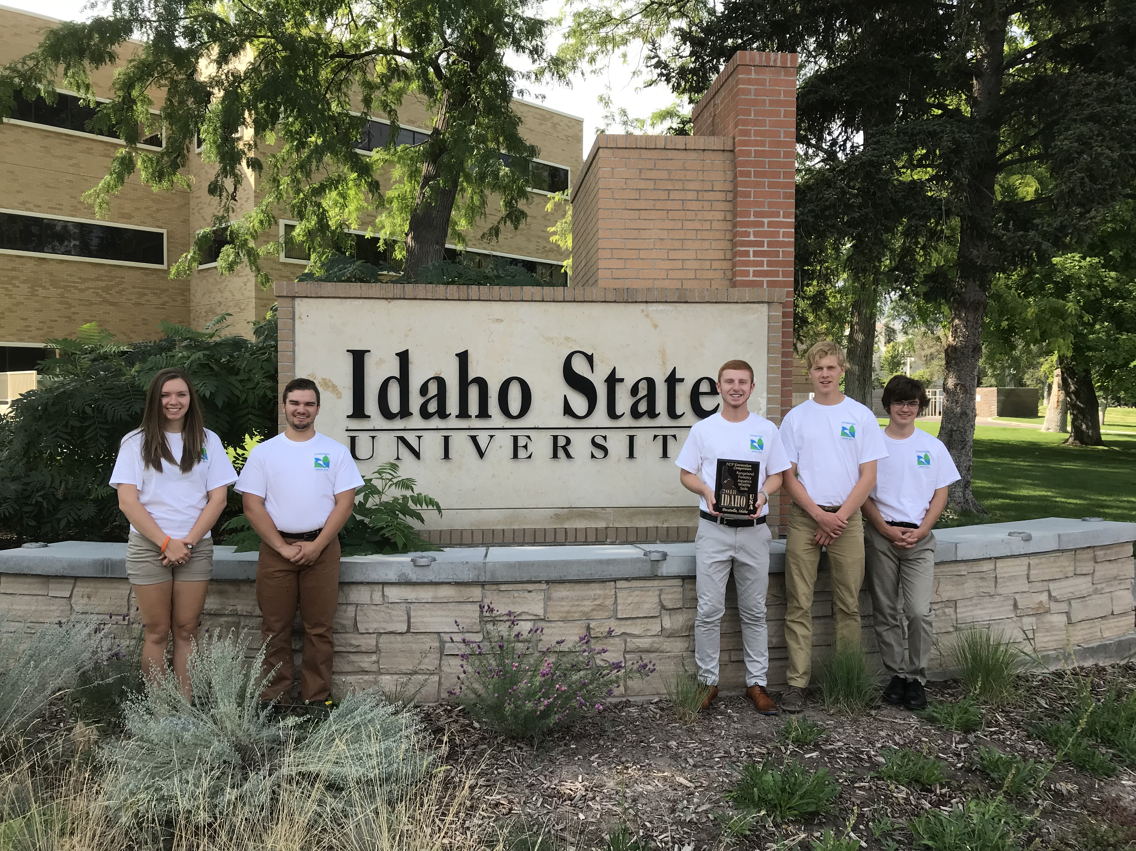
The team score of 95.5 out of 100 in Aquatics earned the team a station high score award. In Forestry, the team scored a 93.5, only 2.5 points behind the 95 score of Virginia. In Soils, the team scored a 74, a 16th place finish, and in Wildlife, the team scored an 88, just 7 points behind New Mexico’s high score of 95. On the Current Issue Test on Rangeland Management, the team scored a 68, but this was only 12 points behind the top score of 80 by West Virginia. The Current Issue Oral Presentation required the team to do a 20-minute presentation on their solution to a problem scenario involving improving the output and bottom line while protecting the environment and resources of a massive ranch near Pocatello. The team was asked to take an “integrative and innovative” approach to improving the ranch, which they did by proposing the addition of wind turbines as a revenue and renewable energy source and the use of Pseudomonas fluorescens, an experimental rhizobacterium biopesticide that kills invasive cheatgrass that is destroying huge numbers of square miles of Idaho rangeland. The team also proposed the integration of beaver dam analogs (artificial beaver dams) to improve the condition of streams and water bodies, as well as promoting multiuse public access to promote social justice. The team’s oral presentation score of 163/200 placed them 7th in the category. The team’s combine score of 582 was good enough for 6th place overall.
“I could not be more proud of the team,” said Taylor. “We have zero rangeland in Maine, as we are the most forested state by percentage in the country. The learning curve was really steep, as the kids had to take in so much new information about Idaho in the last 2 months. When we started out, I asked them why do cowboys wear bandanas? They told me it was because cowboys rob banks. After spending a great deal of time on the rangelands of Idaho, they really understand the need for a bandana as an air filter. Most of the soil is loess in origin, which is wind deposited silt. We have very little of this in Maine. They learned a great deal about Idaho’s natural resources.”
In order to prepare and experience first hand the differences between the West and Maine, the team travelled out a day early and did a whirlwind tour, traveling through the states of Utah, Wyoming, and Montana on their way to Pocatello, Idaho. The team got to see desert, high desert, temperate forest, and alpine ecosystems while visiting Grand Teton and Yellowstone National Parks and Massacre Rocks State Park. Team member Rylee Delaney said, “Traveling to the places we visited before the competition was a big help when we competed. Seeing the places and things we were to be tested on was important, as it is so different from Maine.” Orion Schwab added, “I was shocked when we were called up for our awards. There were so many great teams at the competition.”
For senior Jordan Daigle, the event was bittersweet as it was his third consecutive and final opportunity to compete at the NCF Envirothon. Prior to the final presentation he said, “It is hard to believe this is my final Envirothon event.” Jordan’s team’s finished 27th in Ontario in 2016, 16th in Maryland in 2017, and 6th in Idaho. Advisor Rob Taylor said, “I’m going to miss this year’s seniors a great deal. I have had the pleasure of working with Jordy (Daigle) and Bryan (Riley) since the first grade and they were both a big part of the team’s success in Maine and Idaho. The team met at Bryan’s house a few weeks ago to work on solving a practice current issue problem and the kids really work well together. I’ll miss those meetings. I’ll also miss Rylee Delaney, Tanna Herlihy, and Matt Nichols, who are all off to college and were a big part of Envirothon at Spruce Mountain.”
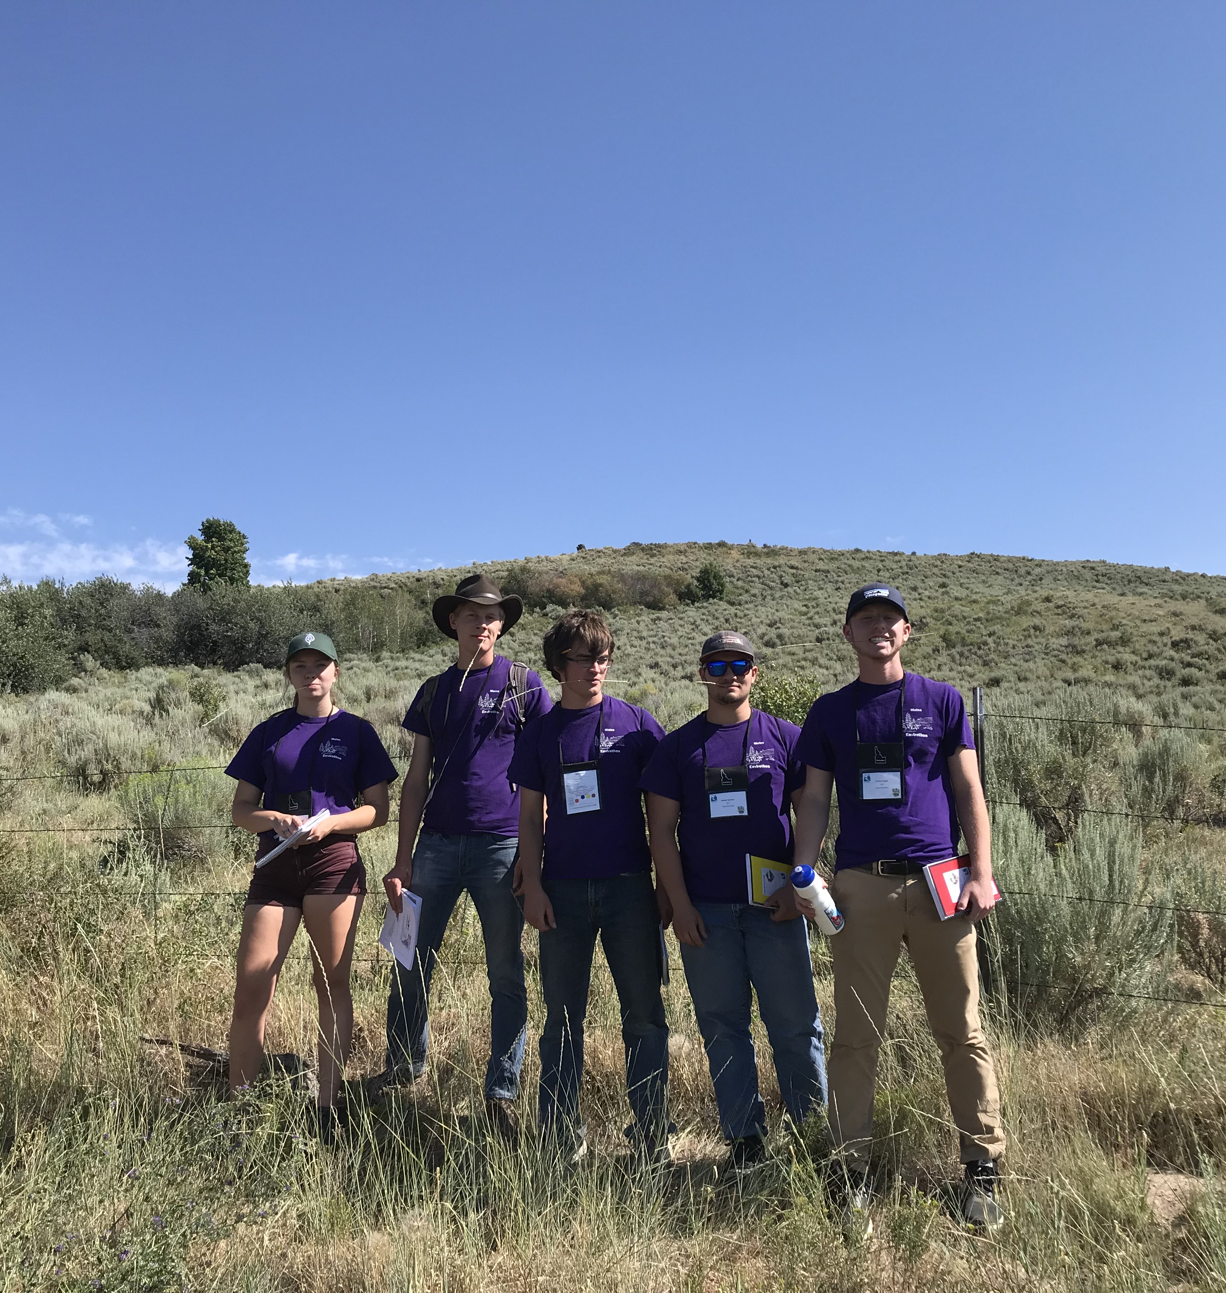
On July 2nd, the team also had a video conference with Kelsey Ramerth, a soil conservationist currently working in Fort Kent who has spent a great deal of time working on rangeland conservation. “Kelsey’s assistance was incredibly helpful and the kids used a lot of what they learned from her in their presentation.” said Taylor. The team would like to thank all of the generous sponsors and technical advisors who made our trip to the NCF Envirothon possible. Without support the team certainly could not have achieved all it did. The sponsors include:

Technical Support
Kelsey Ramerth - Soil Conservationist USDA - NRCS Fort Kent Field Office
Rebecca Jacobs – Education Coordinator - Knox Lincoln Soil and Water District
Marco Grimaldi – Sunset Farm
Maine Association of Conservation Districts
Financial / In Kind Sponsors specifically for the Spruce Mt. Idaho competition

Maine Assis of Conservation Districts
Finley's Funeral Home
McCallister Accounting
Franklin Savings Bank
Otis Federal Credit Union
Hilltop Autobody
Livermore Falls Water District
Dr. William Beaker
Guild's Country Hardware
Main Land Development
Jay Livermore Falls Lions Club
T and L Automotive
PalletOne
Eagle Creek Renewable Energy
Spruce Mountain Pharmacy
Innovative Industries
Jean Castonguay Logging
Re Energy
Maurais and Son Plumbing & Heating
Androscoggin Bank
Amvets Auxiliary Post 33
Amvets Post 33
Dube’s Redemption
St Rose Parish Block Party
Otis Credit Union Tag Day Donors
Riverside Quickstop
Hannaford Supermarkets
Regional School Unit 73
Alan and Linda Cartwright
John and Brenda Yeadon
Linda Olson
Brenner Family
Grimaldi and Ouellette Families

We also wish to thank the Maine Envirothon sponsors who supported the State of Maine competitions which led to Spruce Mountain’s opportunity to compete in Idaho

Cabot Creamery Coop
GZA GeoEnvironmental/Portland
Katahdin Trust Company
Kennebec Savings Bank
Machias Savings Bank
Maine Assoc. of Pro. Soil Scientists
Maine Assoc. of Site Evaluators
Maine Assoc. of Wetland Scientists
Maine Farmland Trust
Maine Turnpike Authority
Oakhurst Dairy
Society of Soil Scientists of Northern New England
Unitel
Unity College
University of Maine [Forestry Dept]
USDA-NRCS-Maine State Office
Weymouth Insurance Group

